QR Code Phishing Detector

MINI PROJECT REPORT
OF INTERNSHIP

BACHELOR OF TECHNOLOGY
COMPUTER SCIENCE AND ENGINEERING

Submitted
To



Dr. A.P.J. ABDUL KALAM TECHNICAL UNIVERSITY LUCKNOW

SUBMITTED BY
SHAMBHWI PRIYA
University Roll No. 2300100100361

UNDER THE SUPERVISION OF
Mr. Ayush Kumar


UNITED COLLEGE OF ENGINEERING & RESEARCH, PRAYAGRAJ, 2025-26

INDEX
1. Introduction
2. Feasibility Study
3. Methodology / Planning of Work
4. Facilities Required
5. DFD(Data Flow Diagram)
6. Working / Snapshots of Result
7. Conclusion
8. References / Bibliography

Introduction
In the digital age, the adoption of Quick Response (QR) codes has grown rapidly across multiple domains such as mobile payments, online shopping, transportation, restaurant services, authentication, and promotional campaigns. QR codes provide a fast, efficient, and user-friendly means of accessing information by simply scanning with a smartphone camera. This convenience has made them an integral part of daily life, especially in cashless transactions and contactless communication. However, the widespread use of QR codes has also created opportunities for malicious exploitation. Cybercriminals increasingly leverage QR codes as vectors for phishing attacks, embedding harmful or deceptive URLs that can mislead users into visiting fraudulent websites or downloading malicious content.
Unlike traditional web links that users can review before clicking, QR codes conceal their actual payload until after they are scanned. This inherent lack of transparency creates a significant security risk, as unsuspecting users may unknowingly expose their devices and personal data to cyber threats. Phishing via QR codes is particularly dangerous because it bypasses many conventional security mechanisms. For example, attackers can use shortened URLs, obfuscated domains, or visually deceptive names that appear trustworthy but actually redirect to malicious websites designed to steal sensitive information such as banking credentials, login details, or private files.
The QR Code Phishing Detector project seeks to mitigate these risks by offering an accessible, browser-based tool capable of decoding QR images and analyzing their contents for potential threats. The system applies heuristic checks to identify insecure practices such as the use of unencrypted “http” links, direct IP addresses instead of domain names, unusually long URLs that may indicate obfuscation, suspicious keyword patterns, and known URL shortener services that often conceal phishing redirects. In addition, the tool highlights possible cases of typosquatting, where attackers register deceptive domains resembling legitimate services (e.g., “paypa1” instead of “paypal”). By alerting users in real time and classifying QR content as safe, suspicious, or unknown, the detector empowers individuals to make informed decisions before interacting with potentially harmful resources.
This project not only raises awareness about the growing problem of QR-based phishing but also demonstrates the practicality of deploying lightweight, client-side protection mechanisms. Since the detection logic operates entirely in the browser using open-source libraries such as jsQR, the solution is privacy-friendly and requires no server-side processing. Overall, the QR Code Phishing Detector represents a proactive step towards strengthening user security in everyday digital interactions and highlights the importance of integrating preventive measures against evolving phishing techniques.

Feasibility Study
Before developing any project, it is essential to evaluate its feasibility to ensure that the proposed system can be implemented effectively within the given constraints. A feasibility study helps in determining whether the project is practical, cost-effective, and suitable for the intended environment. The QR Code Phishing Detector project has been analyzed in terms of technical, economic, operational, and time feasibility.
1. Technical Feasibility
The technical feasibility examines whether the existing technology and tools are sufficient to implement the system. The proposed QR Code Phishing Detector is highly feasible from a technical perspective. It relies on open-source libraries such as jsQR for decoding QR codes and simple JavaScript functions for heuristic checks. These technologies are widely available, easy to integrate, and do not require advanced infrastructure. The project can run on any modern web browser without additional installations. Moreover, the lightweight nature of the system ensures compatibility across devices, including laptops and smartphones. This makes the project technically practical and scalable for academic as well as real-world use.
2. Economic Feasibility
Economic feasibility evaluates the cost requirements of the project. Since the proposed system is entirely based on open-source libraries and does not demand expensive hardware or proprietary software, the cost of implementation is minimal. The project can be developed using free tools and platforms, with no recurring licensing fees. Optional enhancements, such as integration with APIs like Google Safe Browsing or VirusTotal, may require limited free or low-cost API credits, but these expenses are negligible in comparison to the overall benefits. Thus, the QR Code Phishing Detector is economically feasible for both academic projects and practical deployments.
3. Operational Feasibility
Operational feasibility determines whether the system will function effectively in its intended environment. The proposed detector is easy to use, requiring only the upload of a QR code image followed by an automated check. The user interface is simple and intuitive, making it accessible even for non-technical users. Since all processes run locally in the browser, the system does not depend on external servers, ensuring privacy and reliability. Additionally, the system directly addresses a real-world security problem, making its use both relevant and beneficial in everyday digital interactions.
4. Time Feasibility
Time feasibility considers whether the system can be developed and deployed within a reasonable timeframe. Given the simplicity of the tools and libraries involved, the QR Code Phishing Detector can be implemented within a short development cycle. The core functionality of decoding and basic heuristic checks can be completed within a few weeks, while additional features like API integration or improved analytics can be added gradually. Therefore, the project is time-efficient and well-suited for academic deadlines or small-scale deployment.

Methodology / Planning of Work
The development of the QR Code Phishing Detector follows a structured methodology that ensures systematic implementation, testing, and deployment. The project uses a client-side web application model that runs directly in the browser, making it lightweight, user-friendly, and privacy-focused. The methodology can be described in the following stages:
1. Requirement Analysis
The first stage involves understanding the problem domain and identifying essential requirements. Since QR codes often hide URLs that may redirect to phishing websites, the system must:
- Decode QR images reliably.
- Analyze the extracted payload.
- Classify the content as safe, suspicious, or unknown.
- Provide users with clear warnings and recommendations.
2. System Design
The system is designed as a simple web interface that accepts a QR image from the user. The design includes:
- Frontend: Built using HTML, CSS, and JavaScript for a clean, responsive interface.
- QR Decoder: Uses the jsQR library to extract text/URL data from the uploaded image.
- Detection Engine: Implements heuristic checks on the extracted content.
- Output Panel: Displays results with color-coded classifications (safe = green, suspicious = yellow, unknown = blue).
3. Implementation
The working of the detector is implemented as follows:
- QR Upload: The user uploads a QR code image through the interface.
- Image Processing: The uploaded image is rendered on an HTML <canvas> element.
- QR Decoding: The jsQR library analyzes the pixel data and extracts the QR content (URL or text).
- Heuristic Analysis: A JavaScript function (checkURL) evaluates the extracted text using multiple rules:
- Detects http:// links (flagged as suspicious).
- shortened URLs (e.g., bit.ly, tinyurl).
- Checks for direct IP addresses in the URL.
- Flags excessively long URLs (>100 characters).
- Detects typo-squatted domains (e.g., paypa1, g00gle).
- Classifies non-URLs as unknown.

- Result Display: The system shows the decoded content along with the detection status and reason. Safe links are made clickable, while suspicious ones include warning messages.
4. Testing and Validation
The system is tested with a dataset of both safe and malicious QR codes. Example scenarios include:
- Legitimate HTTPS URLs (classified as safe).
- Phishing URLs with typo domains or IP addresses (classified as suspicious).
- QR codes with plain text (classified as unknown).
- Outcome
Through this methodology, the system successfully provides real-time detection of potentially harmful QR codes. The lightweight approach ensures usability, while heuristic checks address common phishing patterns effectively.

Facilities Required
For the successful development and execution of the QR Code Phishing Detector project, certain facilities and resources are necessary. These facilities ensure that the project can be implemented smoothly, tested effectively, and demonstrated without technical hurdles. The requirements can be categorized into hardware, software, human, and network facilities as follows:
1. Hardware Facilities
- A personal computer or laptop with minimum configuration of:
  - Processor: Dual-core (i3 or higher recommended)
  - RAM: 4 GB (8 GB preferred for smooth testing)
  - Storage: 250 GB or more
  - Camera-enabled device (smartphone or webcam) for live QR scanning (optional).
- Reliable display unit for presenting results and demonstration.
2. Software Facilities
- Frontend Development Tools: HTML5, CSS3, JavaScript for creating the user interface.
- Libraries: jsQR (JavaScript QR decoding library).
- Code Editor: Visual Studio Code or any equivalent IDE.
- Browser Support: Google Chrome, Mozilla Firefox, or Microsoft Edge (latest versions).
- Optional APIs: Google Safe Browsing or VirusTotal for reputation checks.
- Version control (Git/GitHub) for maintaining project source code.
3. Human Facilities
- Developer(s) with basic knowledge of web development (HTML, CSS, JS).
- Guidance and supervision from faculty/project mentor.
- Test users for validating the system with safe and malicious QR codes.
4. Network Facilities
- Stable internet connection for:
  - Accessing online libraries (CDN for jsQR).
  - Downloading dependencies and updates.
  - Testing external URLs when scanning QR codes.
  - Using reputation-checking APIs (if integrated).
- Local network for sharing project demo within institution.
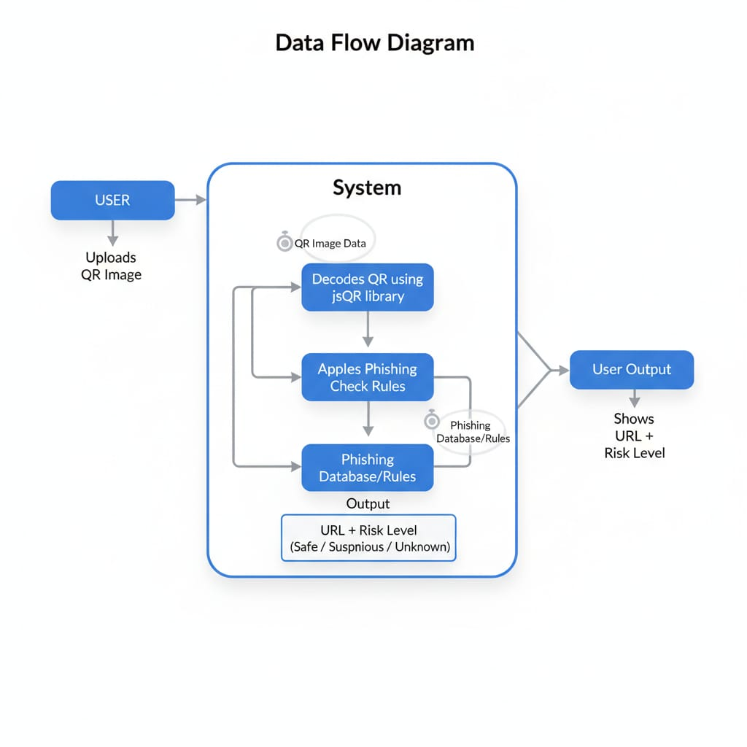
Working / Snapshots of Result

Conclusion
The facilities required for this project are minimal and can be easily arranged in a typical academic or research environment. With just a standard computer, free open-source software, and basic internet access, the QR Code Phishing Detector can be developed, tested, and deployed successfully. This makes the project highly feasible and accessible to students, educators, and researchers.

References/Bibliography
- jsQR Library Documentation – https://github.com/cozmo/jsQR
- Mozilla Developer Network (MDN), JavaScript Documentation – https://developer.mozilla.org/
- W3Schools, HTML and CSS Tutorials – https://www.w3schools.com/
- ECMAScript Language Specification (JavaScript Standard), 2023.
- TutorialsPoint, HTML5 Canvas and JavaScript Basics, 2023.
- Google Chrome Developers, Web Platform APIs and Browser Support, 2024.

